**THE UNIVERSITY OF AZAD JAMMU AND KASHMIR**



__________________________________________

|  |  |
| --- | --- |
| COURSE TITLE | CA&LD |
| COURSE CODE | CS-1205 |
| TITLE | De Morgan’s law |
| STUDENT NAME | Tayyab Hanif |
| STUDENT ROLL NUMBER | 2024-SE-11 |
| INSTRUCTOR NAME | Engr. Sidra Rafique |
| Lab No: | 04 |

**Lab 4: Verification of De Morgan’s Laws**

**Objective**

To verify De Morgan’s Theorems using basic logic gates by constructing and testing digital circuits for each law individually.

**Apparatus Required**

Breadboard

Logic gate ICs (IC 7408 - AND, IC 7432 - OR, IC 7404 - NOT)

Power Supply (5V DC)

Connecting Wires

Logic Probes or LEDs for Output Verification

**Theory**

De Morgan’s Theorems are two transformation rules that are used to simplify logic expressions and to implement logic functions in terms of NAND and NOR gates.

**First Law**

¬(A + B) = ¬A · ¬B

This law states that the complement of the logical OR of two variables is equal to the logical AND of their individual complements.

**Second Law**

¬(A · B) = ¬A + ¬B

This law states that the complement of the logical AND of two variables is equal to the logical OR of their individual complements.

**Part A – Verification of First De Morgan’s Law**

**Boolean Expression**

¬(A + B) = ¬A · ¬B

**Circuit 1: Left-hand side (¬(A + B))**

Connect two inputs A and B to an OR gate.

Connect the output of the OR gate to a NOT gate.

The output of the NOT gate represents ¬(A + B).

**Circuit 2: Right-hand side (¬A · ¬B)**

Connect input A to a NOT gate to get ¬A.

Connect input B to another NOT gate to get ¬B.

Connect the outputs of both NOT gates to an AND gate.

The output of the AND gate represents ¬A · ¬B.

**Truth Table – First Law**

|  |  |  |  |  |  |  |
| --- | --- | --- | --- | --- | --- | --- |
| A | B | A + B | ¬(A + B) | ¬A | ¬B | ¬A · ¬B |
| 0 | 0 | 0 | 1 | 1 | 1 | 1 |
| 0 | 1 | 1 | 0 | 1 | 0 | 0 |
| 1 | 0 | 1 | 0 | 0 | 1 | 0 |
| 1 | 1 | 1 | 0 | 0 | 0 | 0 |
|  |  |  |  |  |  |  |

**Observation**

The output values of ¬(A + B) and ¬A · ¬B are identical for all possible input combinations. Thus, the First De Morgan’s Law is verified.

**IC Circuit**

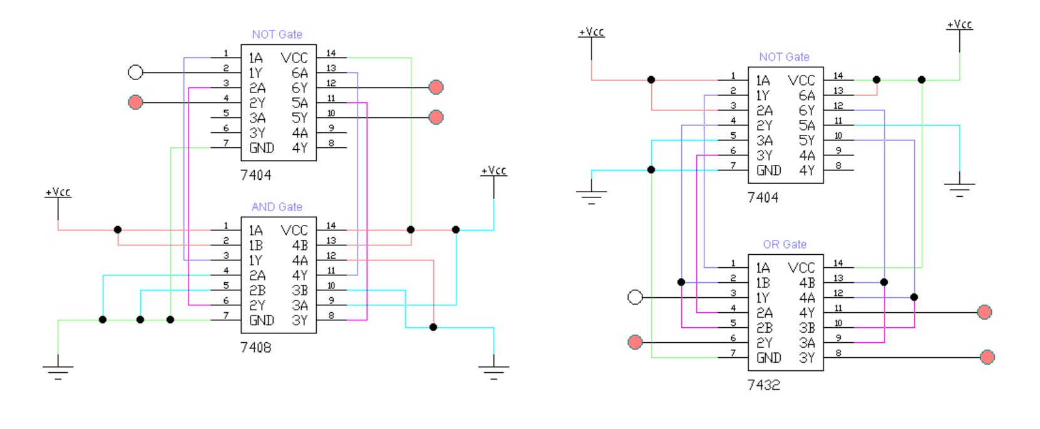

**Truth Table**

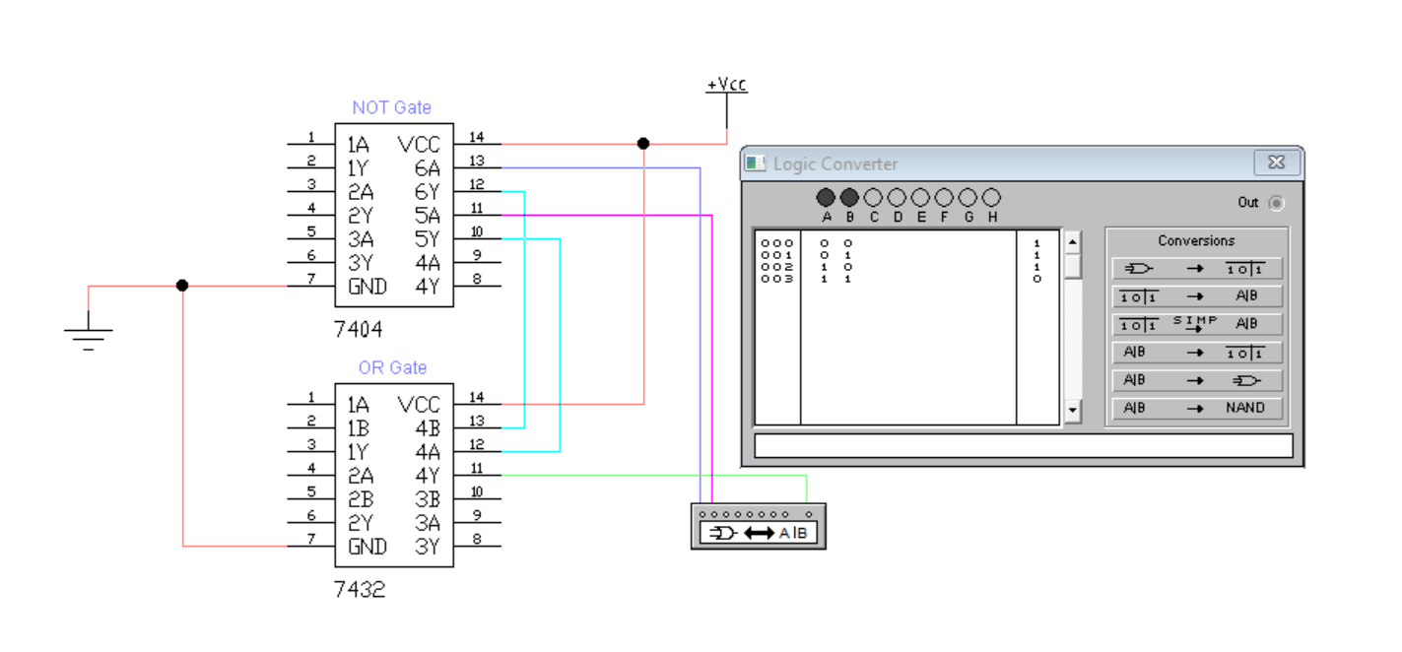

**Implementation**

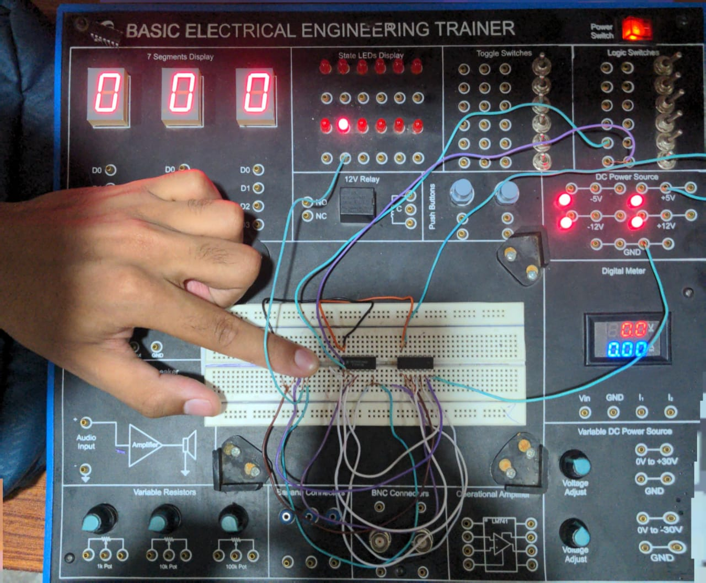

**Part B – Verification of Second De Morgan’s Law**

**Boolean Expression**

¬(A · B) = ¬A + ¬B

**Circuit 1: Left-hand side (¬(A · B))**

Connect two inputs A and B to an AND gate.

Connect the output of the AND gate to a NOT gate.

The output of the NOT gate represents ¬(A · B).

**Circuit 2: Right-hand side (¬A + ¬B)**

Connect input A to a NOT gate to get ¬A.

Connect input B to another NOT gate to get ¬B.

Connect the outputs of both NOT gates to an OR gate.

The output of the OR gate represents ¬A + ¬B.

|  |  |  |  |  |  |  |  |  |  |  |  |  |  |  |  |  |  |  |  |  |  |  |  |  |  |  |  |  |  |  |  |  |  |  |  |  |  |  |  |  |  |
| --- | --- | --- | --- | --- | --- | --- | --- | --- | --- | --- | --- | --- | --- | --- | --- | --- | --- | --- | --- | --- | --- | --- | --- | --- | --- | --- | --- | --- | --- | --- | --- | --- | --- | --- | --- | --- | --- | --- | --- | --- | --- |
| **Truth Table – Second Law**   |  |  |  |  |  |  |  | | --- | --- | --- | --- | --- | --- | --- | | A | B | A · B | ¬(A · B) | ¬A | ¬B | ¬A + ¬B | | 0 | 0 | 0 | 1 | 1 | 1 | 1 | | 0 | 1 | 0 | 1 | 1 | 0 | 1 | | 1 | 0 | 0 | 1 | 0 | 1 | 1 | | 1 | 1 | 1 | 0 | 0 | 0 | 0 |   **IC Circuit**    **Truth Table**    **Implementation** |  |  |  |  |  |  |

**Observation**

The output values of ¬(A · B) and ¬A + ¬B are identical for all input combinations. Thus, the Second De Morgan’s Law is also verified.

**Conclusion**

The practical implementation and comparison of logic gate circuits confirm the validity of De Morgan’s Theorems. Both theorems were verified successfully through truth tables and logic gate outputs.